1. **What is assumption made while multiplying individual likelihood ratios? - 3 points**

In my opinion the underlying assumption is that one likelihood ratio's result has no bearing on another one.

1. **List the names of indices that are designed to address multiple morbidities. - 3 points**

Charlson indices, Comorbidity indices, Multimorbidity indices etc.

1. **Is the multi morbidity index different in a person with coma when compared to a person without coma? Does presence of rare diseases increase the probability of death? - 4 points**

Multimorbidity is the co-existence of two or more diseases. Multimorbidity patients need a lot of the healthcare system's assets. To figure out the extent of trauma and estimate the status of trauma patients, numerous scoring systems have been created in recent years. In order to predict the in-hospital mortality of trauma patients, this study compared REMS, MEWS, ISS, and GCS. The severity of a brain injury and a person's degree of consciousness are determined by the Glasgow Coma Scale (GCS). All acute medical and trauma patients are evaluated using this scale, which is utilized by emergency assistance, nurses, and doctors.

Over than 175,000 Americans every year die from trauma and serious injuries, which are also the main cause of death for persons under the age of 45. Trauma also leads to significant problems, disabilities, and monetary and social expenses. Early diagnosis, proper triage, and prompt treatment reduce hospital fatalities and are economical. In recent years, a number of scoring systems have been put into place to evaluate the severity of the wounds and identify which patients require close monitoring, specialized care, and the proper distribution of care services.

1. **Deduce the likelihood ratio formula for the following contigency matrices: - 20 points (5 points per sub question)**
2. L Diagnosis =

$$\frac{\text{P (Dx| Patients with Outcome)}}{\text{P (Dx| Patients without Outcome)}}$$

= $\frac{a/{a+c}}{b/{b + d}}$

If “a” or “c” is 0, then make it 1.

2. L Diagnosis =

$$\frac{\text{P (Dx| Patients with Outcome)}}{\text{P (Dx| Patients without Outcome)}}$$

= $\frac{b/{b+d}}{a/{a+c}}$

If “b” or “d” is 0, then make it 1.

1. L Diagnosis =

$$\frac{\text{P (Dx| Patients with Outcome)}}{\text{P (Dx| Patients without Outcome)}}$$

= $\frac{d/{b+d}}{c/{a+c}}$

If “d” or “b” is 0, then make it 1.

1. L Diagnosis =

$$\frac{\text{P (Dx| Patients with Outcome)}}{\text{P (Dx| Patients without Outcome)}}$$

= $\frac{c/{a+c}}{d/{b+d}}$

If “c” or “d” is 0, then make it 1.

1. **Clean the attached**[**Data**](https://mymasonportal.gmu.edu/bbcswebdav/pid-17077198-dt-content-rid-273244395_1/xid-273244395_1)**. On completing the task, provide the number of records left in the data as your final answer. Password for the data set is "Avramovic". Clean the attached data by removing**
   1. **Patients who have negative age**
   2. **Repeated diagnoses for the same patient at the same age - 30 points**

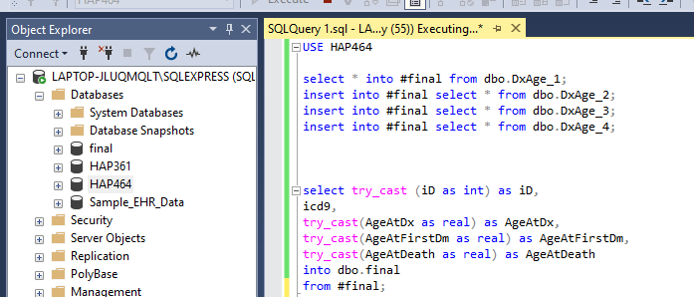

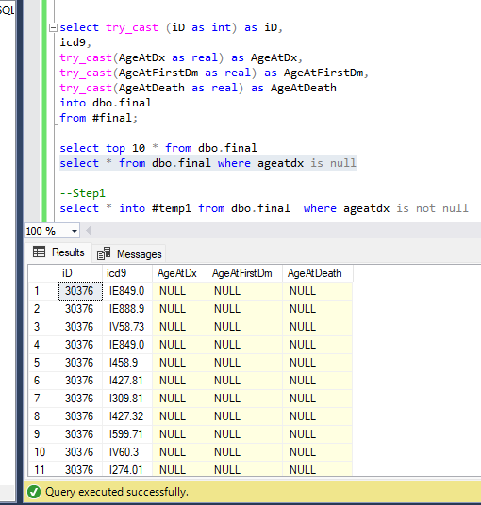

**b.Repeated diagnoses for the same patient at the same age - 30 points**

1. **For the patient in the cleaned data, calculate the likelihood ratios associated with each diagnosis predicting mortality in 6-months - 40 points**

